02/19
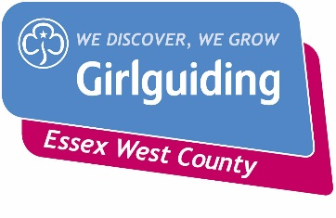

Non-Charged Badges Order Form

These should be ordered via County Office in writing, no email or telephone orders will be accepted. When ordering Long Service Awards, please let the office know the date they are presented and to who, so their record can be updated on GO.

Girlguiding Essex West, Suite 1, Bates Business Centre, Church Road, Harold Wood, Romford, RM3 0JF
Tel: 01708 373746. Email: office@girlguidingessexwest.org.uk

Order code | Badge name | Quantity
1603 | Y/L Qualification (Metal) + Cert
1227 | Good Service Brooch + Cert
2684 | 5yr Service Badge + Cert (Metal)
2700A | 10yr Service Badge + Cert (Metal)
2701A | 20yr Service Badge + Cert (Metal)
2702 | 30yr Service Badge + Cert (Metal)
2703 | 40yr Service Badge + Cert (Metal)
2704 | 50yr Service Badge + Cert (Metal)
2711 | 60yr Service Badge + Cert (Metal)
6353 | 5yr Service Certificate non-member
6354 | 10yr Service Certificate non-member
6355 | 20yr Service Certificate non-member
6356 | 30yr Service Certificate non-member
6357 | 40yr Service Certificate non-member
6358 | 50yr Service Certificate non-member
1249 | Queens Guide Silver brooch + Cert  Name of recipient ………………………………………

NAME: ………………………………………………………………………………………………………….
ADDRESS: …………………………………………………………………………………………………….
POST CODE: ………………………E-MAIL: ……………………………………………………………….
MEMBERSHIP NUMBER: ……………………………………………………………………………………

