Essex West  Achievement Award for Young Members | 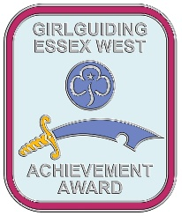

The Essex West Achievement award is designed to recognise those young members under 18 years old who stand out from the crowd and are an inspiration to others.

Criteria

- Rainbows / Brownies – Exceptional observance of the promise or law which demonstrates the true spirit of guiding.

- Guides / Young leaders - Outstanding observance of one or more of the Guide Laws which demonstrates the true spirit of guiding.

Another member of Girlguiding must support this nomination, ideally this should be a young member.

All applications must be made without the knowledge of the nominee or her family. Any leader may make an application.

Name of nominee:  DOB: |  | Unit:  District:  Division:  Membership number:
This application is made by  Name :  Signed: _________________________________  Date:  Role:  Unit:  Membership number : | This application is supported by  Name :  Signed:  Date:  Role:  Unit:  Membership number:

Please explain what the young member has done and why this should be recognised:

TO BE COMPLETED BY THE YOUNG MEMBER WHO IS SUPPORTING THIS NOMINATION
(With younger girls, the leader can write what they have to say)

Please tell us what this person has done to deserve an achievement award:

Decision of awards panel
Date:

