Girlguiding Anglia Buddy Award
Within Girlguiding Anglia, we would like to recognise the often un-noticed work of girls and young women who act as Buddies within units and at events. Their work enables our members with special needs to experience the amazing opportunities offered within guiding.
To nominate someone for the Girlguiding Anglia Buddy Award they need to meet the following criteria:
- Be aged 25 and under and a member of Girlguiding Anglia.
- Have worked as a Buddy to support a member or members with special needs for at least 25 hours. This must be on at least three separate occasions.
The nomination should be made by a unit Leader and, where possible, supported in some way by the young member(s) with whom they work.
The award is a metal badge (pictured top right) and this should be presented along with the personalised certificate (provided by Region) at an appropriate occasion, to show the importance of the work carried out by the recipient.
If you would like someone to be considered for this award, please complete the attached form and return it to Anna Johns either by email: annaj@girlguiding-anglia.org.uk or by post: Girlguiding Anglia Office, 7 Great Hautbois Road, Coltishall, Norwich, Norfolk, NR12 7JN.

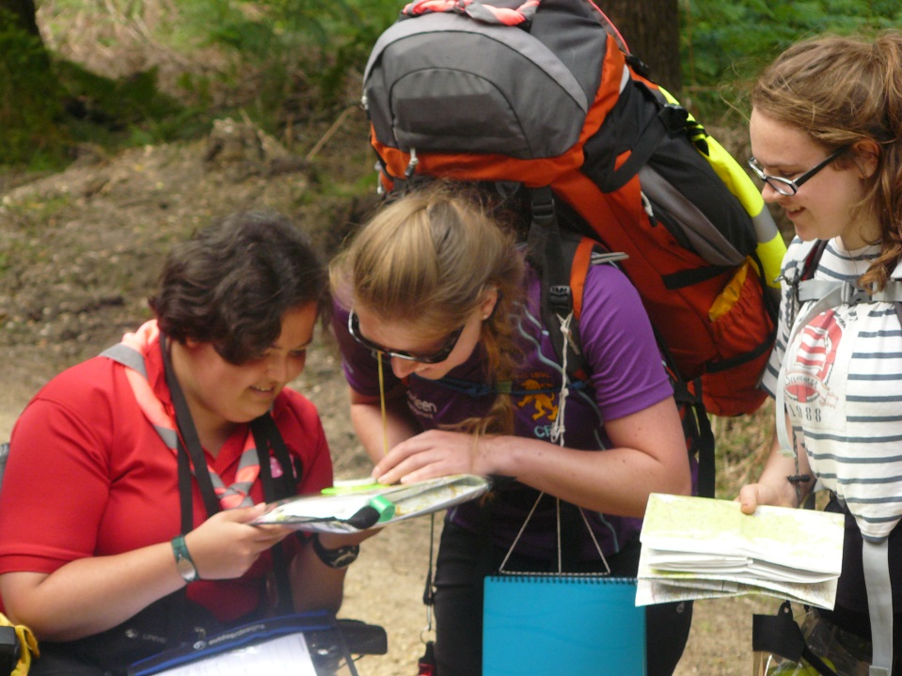

Girlguiding Anglia Buddy Award
Unit Leader Name:
Unit Leader Membership Number:
Unit Name:
Name of Nominee:
Membership Number of Nominee:
Person or Group supported by the Nominee:
Length and type of support given:

Any comments from the young member(s) supported by the Nominee:

Signed:
Dated:

For Office Use
Sign and date received | Date passed to Adviser for Members with Special Needs | Date approved
Details sent to Chair of Awards Committee | Date sent to local commissioner | Date presented

