Girlguiding Anglia Buddy Award
Within Girlguiding Anglia, we would like to recognise the Units which contain girls and young women who regularly help and support members with special needs in those Units each week during their meetings. Their support enables our members with special needs to experience the amazing opportunities offered within guiding and be included in Unit activities.
To nominate a Unit for the Girlguiding Anglia Buddy Award they need to meet the following criteria:
- The Unit must be within Girlguiding Anglia.
- The Unit must have supported a member or members with special needs for at least 25 hours. This must be on at least three separate occasions.
The nomination should be made by a District Commissioner and, where possible, supported in some way by the young member(s) with whom they work.
The award is a cloth badge for each member of the Unit and this should be presented along with the personalised certificate (provided by Region) at an appropriate occasion, to show the importance of the work carried out by the Unit.
If you would like a Unit to be considered for this award, please complete the attached form and return it to Anna Johns either by email: annaj@girlguiding-anglia.org.uk or by post: Girlguiding Anglia Office, 7 Great Hautbois Road, Coltishall, Norwich, Norfolk, NR12 7JN.
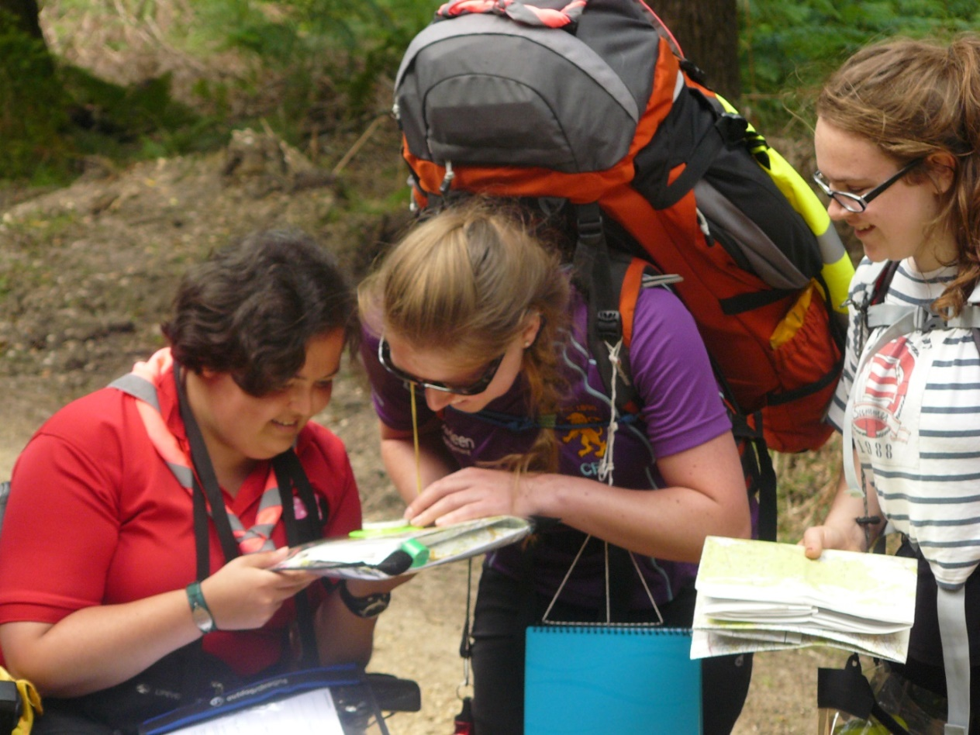

Girlguiding Anglia Buddy Unit Award
Unit Leader Name:
Unit Leader Membership Number:
Unit Name:
Name of Nominee:
Membership Number of Nominee:
Person or Group supported by the Nominee:
Length and type of support given:

Any comments from the young member(s) supported by the Nominee:

Signed:
Dated:
For Office Use
Sign and date received | Date passed to Adviser for Members with Special Needs | Date approved
Details sent to Chair of Awards Committee | Date sent to local commissioner | Date presented

