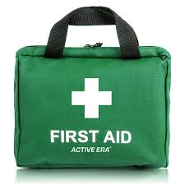

First Response Training

The Trainers are offering the following evenings for a complete First Response course.

You must also complete the e-learning module on-line. This may be done before or after these evenings, but the qualification cannot be entered on GO until it is completed.

DATE | MODULE | Venue | TIME
Monday 18th October 2021 | Module 2 | Zoom | 7.30 p.m.
Monday 1st November 2021 | Module 3 | Zoom | 7.30 p.m.
Monday 8th November 2021 | Module 1 – face-to-face | Gidea Park | tbc

Please complete the attached form and email to County Office to book your place.

Remember that the 2-hour renewal option is no longer available.

------------------------------------------------------------------------------------------------------------------------------------------------

First Response Training October/November 2021

Name …………………………………………… Division ………………………………………

Membership Number ………………………

Unit ……………………………………………………….Rainbows/Brownies/Guides/Rangers

Telephone………………………… Email ……………………………………………………………………

Reply to:-Girlguiding Essex West – office@girlguidingessexwest.org.uk

Once you have booked the zoom links will be sent to you

