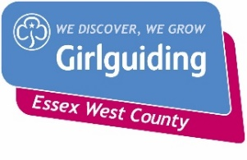 | Face-to-Face  Safe Space Level 3 Training

THURSDAY 11th NOVEMBER 2021

6.45 – 9.45 p.m.

St. PETER’S CHURCH, GUBBINS LANE, HAROLD WOOD. RM3 0QA

Please complete the attached form and email to County Office to book your place.

Places are limited to 20 Leaders

------------------------------------------------------------------------------------------------------------------------------------------------

Safe Space Level 3 Training – 11th November 2021

Name …………………………………………… Division ………………………………………

Membership Number ………………………

Unit ……………………………………………………….Rainbows/Brownies/Guides/Rangers

Telephone………………………… Email ……………………………………………………………………

Reply to:-Girlguiding Essex West – office@girlguidingessexwest.org.uk

