GIRLGUIDING ESSEX WEST PROGRAMME & ADVENTURE

TEAM BUILDING/FUN DAY
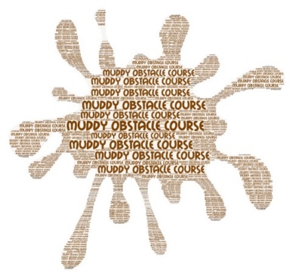
RANGERS – YOUNG LEADERS – GUIDES 13+
MUDDY OBSTACLE COURSE

WHERE: Wild Forest Obstacle Activity Centre
Parsonage Farm, Kelvedon Hatch, Brentwood, Essex CM15 0LA

WHEN: 10th April 2022

TIME: 10.30 a.m. – Noon

COST: £20.00 per person

This event for Rangers, Young Leaders and older Guides involves mud, obstacles and lot of fun!
Your Mission should you choose to accept it will be to:
Complete the course with your team and come back with the most rewards!

A dedicated member of the Wild Forest crew will be with teams at all times.

The course will last 90 minutes.

Hot outdoor showers (quick rinse off, but shampoo and shower gel not to be used).
Changing rooms available.

Please return slip with your payment of £20 and SAE to County Office, Suite T4, Bates Business Centre, Church Road, Harold Wood, Romford. RM3 0JF (Closing Date for Entries: 20th March 2022)

***Please Note: If the morning event is oversubscribed, we will run an afternoon event on the same day***

-------------------------------------------------------------------------------------------------------------------

ESSEX WEST MUD RUN – 10th APRIL 2022

NAME ………………………………………………………….. AGE ………………………

UNIT NAME …………………………………………………... DIVISION ………………

CONTACT EMAIL ……………………………………………………………………………………………

TELEPHONE CONTACT ON THE DAY ……………………………………………………………………

