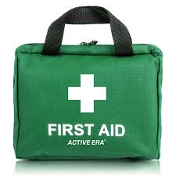

First Response Training

The Trainers are offering a full, all day First Response course.

You must also complete the e-learning module on-line. This may be done before or after the day, but the qualification cannot be entered on GO until it is completed.

DATE | MODULE | Venue | TIME | ATTEND
Sat. 18th May 2024 | Module 1

Please complete the attached form and email to County Office before 8th May 2024 to book your place.
Log on details will then be sent.

Remember that the 2-hour renewal option is no longer available.

------------------------&-----------------------------------------------------------------------------------------------------------

First Response Training May 2024

Name …………………………………………… Division ………………………………………

Membership Number ………………………

Unit ………………………………………………………. Rainbows/Brownies/Guides/Rangers

Telephone………………………… Email ……………………………………………………………………

Reply to:-Girlguiding Essex West – office@girlguidingessexwest.org.uk

Once you have booked the zoom links will be sent to you

