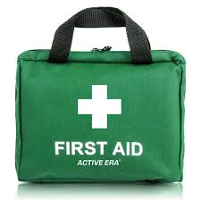

First Response Training

The Trainers are offering the following evenings towards a First Response course. If you only need one of these Modules, that is fine. Just sign up for what you require to complete the qualification.

You must also complete the e-learning module on-line. This may be done before or after these evenings, but the qualification cannot be entered on GO until it is completed. Please note that all 3 Modules are required to gain the qualification.

DATE | MODULE | Venue | TIME | /X
Wed. 26th July 2023 | Module 1- f2f | The Hub, Harold Wood. RM3 0QA | 7.30 p.m.
Wed. 2nd August 2023 | Module 2 | Zoom | 7.30 p.m.
Wed. 9th August 2023 | Module 3 | Zoom | 7.30 p.m.

Please complete the attached form and email to County Office before 21st July to book your place.
Log on details will then be sent.

Remember that the 2-hour renewal option is no longer available.

------------------------&-----------------------------------------------------------------------------------------------------------

First Response Training July/August 2023

Name …………………………………………… Division ………………………………………

Membership Number ………………………

Unit ………………………………………………………. Rainbows/Brownies/Guides/Rangers

Telephone………………………… Email ……………………………………………………………………

Reply to:-Girlguiding Essex West – office@girlguidingessexwest.org.uk

Once you have booked, the zoom links will be sent to you

