Essex West  Achievement Award for Young Members | 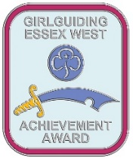

The Essex West Achievement award is designed to recognise those young members under 18 years old who stand out from the crowd and are an inspiration to others.

Criteria

- Exceptional observance of the promise or law which demonstrates the true spirit of guiding.

Another member of Girlguiding must support this nomination, ideally this should be a young member.

All applications must be made without the knowledge of the nominee or her family. Any leader may make an application.

Name of nominee:  DOB: |  | Unit:  District:  Membership number:
This application is made by  Name:  Signed: _________________________________  Date:  Role: Unit:  Membership number: | This application is supported by  Name:  Signed:  Date:  Role: Unit:  Membership number:

Please explain what the young member has done and why this should be recognised:

Please send the completed form to the Awards Chairman sylviapartridge@btinternet.com

