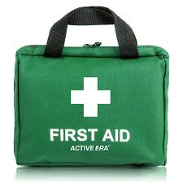

First Response Training

The Trainers are offering the following sessions towards a First Response course. If you only need one of these Modules, that is fine. Just sign up for what you require to complete the qualification.

You must also complete the e-learning module on-line. This may be done before or after these evenings, but the qualification cannot be entered on GO until it is completed. Please note that all 3 Modules are required to gain the qualification.

DATE | MODULE | Venue | TIME | ATTEND
Sat. 16th March 2024 | Module 1 | St. Peters, Harold Wood. RM3 0QA | 9.30 a.m.
Thurs. 21st March 2024 | Module 2 | Zoom | 7.30 p.m.
Mon. 25th March 2024 | Module 3 | Zoom | 7.30 p.m.

Please complete the attached form and email to County Office before 8th March 2024 to book your place.
Log on details will then be sent.

Remember that the 2-hour renewal option is no longer available.

------------------------&-----------------------------------------------------------------------------------------------------------

First Response Training March 2024

Name …………………………………………… Division ………………………………………

Membership Number ………………………

Unit ………………………………………………………. Rainbows/Brownies/Guides/Rangers

Telephone………………………… Email ……………………………………………………………………

Reply to: - Girlguiding Essex West – office@girlguidingessexwest.org.uk

Once you have booked the zoom links will be sent to you

