TEAM BUILDING/FUN DAY
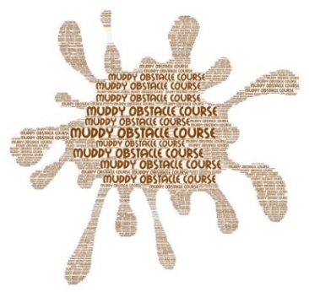
BROWNIES and GUIDES
MUDDY OBSTACLE COURSE

WHERE: Wild Forest Obstacle Activity Centre
Parsonage Farm, Kelvedon Hatch, Brentwood, Essex CM15 0LA

WHEN: 27th April 2024

TIME: 12 noon. – Brownies & 2.30 pm - Guides

COST: £25.00 per person

This event for Brownies and Guides involves mud, obstacles, and lot of fun!
Your Mission, should you choose to accept it will be to:
Complete the course with your team and come back with the most rewards!

A dedicated member of the Wild Forest crew will be with teams at all times.

The course will last 90 minutes.

Hot outdoor showers (quick rinse off, but shampoo and shower gel not to be used).
Changing rooms available.

Please return slip with your payment of £25 and SAE to County Office, Suite T4, Bates Business Centre, Church Road, Harold Wood, Romford. RM3 0JF (Closing Date for Entries: 20th March 2024)

***Please Note: If the morning event is oversubscribed, we will run an afternoon event on the same day***

-------------------------------------------------------------------------------------------------------------------

ESSEX WEST MUD RUN – 27th APRIL 2024

NAME ………………………………………………………….. AGE ………………………

UNIT NAME …………………………………………………... DIVISION ………………

CONTACT EMAIL ……………………………………………………………………………………………

TELEPHONE CONTACT ON THE DAY ……………………………………………………………………

