Carry on Camping
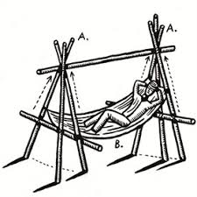
10am Saturday 22 June to 10am Sunday 23 June
(or leave Saturday evening)
Essex West Campsite, Chigwell Row

Are you new to camping or just want to brush up on your camping skills?
Want new ideas of activities for the girls at camp?

We’ve just the thing for you - we are holding an overnight training all about camping and enjoying the great outdoors.

We plan to include fire lighting of all sorts, camp cooking recipes & techniques, gadget building, pitching & repairing tents, tips for camping in all weathers, wide games, planning events, first aid, risk assessments and anything else you suggest.

Don’t fancy camping but still looking to do a residential? Why not come along a lot of what we will be doing is the same when staying indoors.

If you want to come along and enjoy a 24 hour camp, with no girls to keep an eye on, share your skills and learn new ones, fill in the form below by 31 May. Make sure you let us know what else you would like us to include.

Any questions contact Fiona outdoor@girlguidingessexwest.org.uk

--------------------------------------------------------------------------------
Carry on Camping

Please send your application and a non-refundable fee of £10 towards site fees and food to:-
Suite T4, Bates Business Centre, Church Road, Harold Hill, Romford RM3 0JF
Cheques made payable to GUIDE ASSOCIATION ESSEX WEST, or pay via BACS – 20-12-21, 80902551 (reference – camp & name)

Name …………………………………………………………………. Division………………………………………………………...

Unit …………………………………………………………………. Rainbows/Brownies/Guides/Senior Section

Membership Number ………………………………………………………………………………

Telephone ……………………………………………………… email ………………………………………………………………

Please give any ideas of things you would like us to include

