Girlguiding Essex West invites
All its wonderful volunteers to

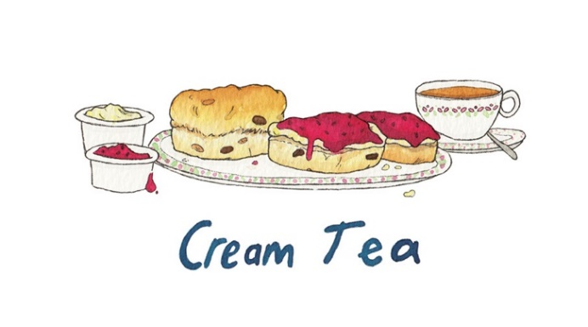
Sunday 7th July 2024
2.00 - 4.00pm

The Barn, Thames Chase Forest Centre
Pike Lane Upminster RM14 3NS

To secure your place please return the slip below with a £5.00 payment. Places are limited so don’t delay- book today!

--------------------------------------------------------------------------------------------------

COUNTY CREAM TEA – 7th JULY 2024

Please send your application and a non-refundable fee of £5 towards costs to: -

Suite T4, Bates Business Centre, Church Road, Harold Hill, Romford RM3 0JF
Payable Via BACS or Cheque payable to GUIDE ASSOCIATION ESSEX WEST

Name …………………………………. Division …………………………………………

Membership Number ……………………………………

Unit …………………………………………Rainbows/Brownies/Guides/Senior Section

Telephone………………………… Email …………………………………………………..

Dietary Requirements ………………………………………………………………………….

